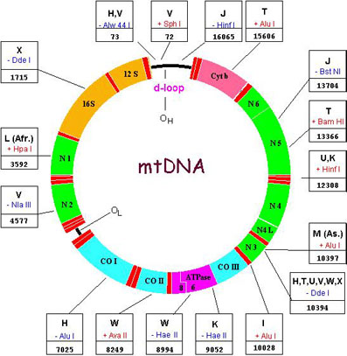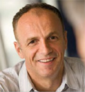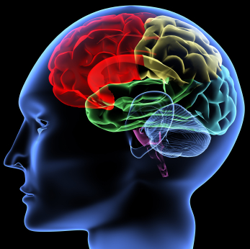

Friday, 25th January 2019
Aalborg University Hospital, Auditorium Syd
Prof. Nick Wood qualified in medicine from the University of Birmingham, went on to take a PhD in Cambridge. In 2004 he was elected to the Fellowship of the Academy of Medical Science and to senior investigator of the NIHR in 2008. He is currently Galton Professor of Genetics, a Consultant Neurologist and Head of the Department of Molecular Neuroscience at the Institute of Neurology and Neurosurgery, Queen Square, London, England. Since 2017adjunct Prof. at Aalborg University Hospital. http://www.ucl.ac.uk/ukpdc/principal-investigators/nick-wood
Disease awareness within clinical Neurology

09.00-09.15 Introduction  09.15-10.00 Aalborg pt I  10.00-10.45 Aarhus pt I  10.45-11.00 Coffebreak | 11.00-11.45 Viborg pt  11.45-12.30 Holstebro pt  12.30-13.15 Lunch | 13:15-14:00 Aalborg pt II  14:00-14:45 Aarhus pt II  14:45-15:00 Coffebreak  15:00-15:45 Videosession
Interactive participation is mandatory.

Patients will be presented by doctors from Aarhus, Holstebro, Viborg and Aalborg under the specialist training scheme, and discussed by the audience. Focus will be on skills in presentation of the patients’ medical history and their symptoms, as well as in performing clinical examination followed by discussion to obtain diagnosis and disease awareness.

Please bring video records from your department on USB for discussion under supervision by Nick Wood (max 3min per video).

Registration secretary Charlotte Pheiffer, +45 97662201, E-mail: cvp@rn.dk

Deadline 21st January 2019

